Before you run the T-Chest Looter, you can modify what level loot it takes. Open the Looter script and you can modify the true/false to set what you want.
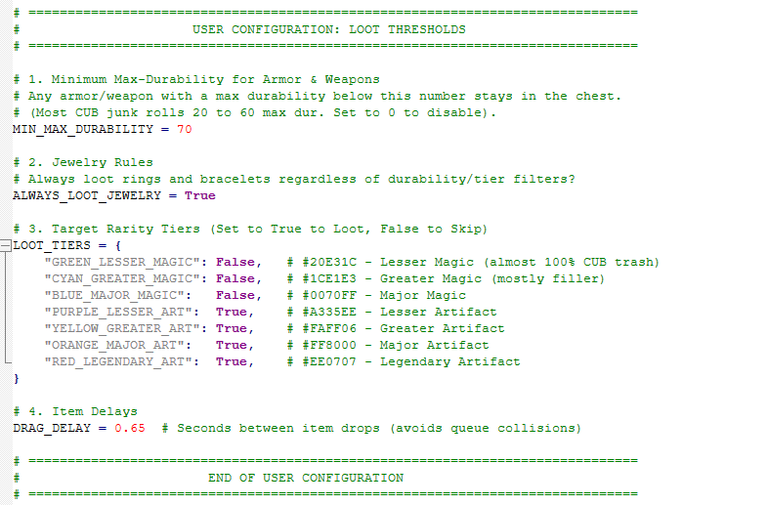

After you set the levels. You simply target the loot bag (on you or a pack animal) then target the chest. The script will pick the lock, remove trap, and loot. If you use the same loot bag on later chests, you will not be prompted for a loot bag. If you switch bags, it will prompt once. If you want to manually clear the loot bag, run the T-Chest Clear Hot Bag script. This simply erases the current bag from memory.

